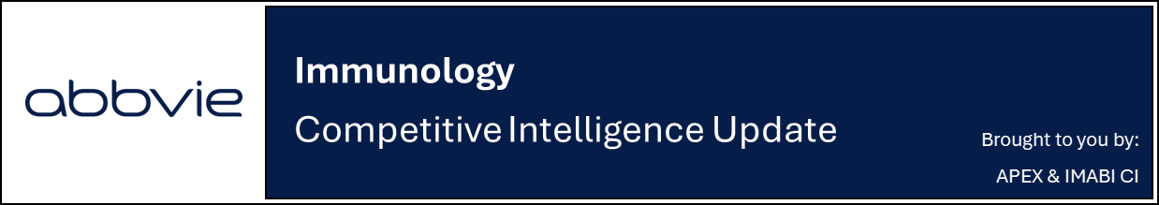
FDA Clears Sonelokimab Phase 2 & 3 Data for BLA Submission

Company: MoonLake Immunotherapeutics  Drug: Sonelokimab (SC, IL-17A/F) | Date: January 8^{th,} 2026  Source(s): Press Release
What happened:
- MoonLake announced positive outcome from the Type B meeting with the FDA for sonelokimab in Hidradenitis Suppurativa (HS)
- FDA has confirmed that no additional trials are required to establish substantial evidence of effectiveness (SEE) and has requested data from the Phase 3 VELA-1 & VELA-2 and Phase 2 MIRA trials for regulatory filing in HS
- MoonLake continues to plan for BLA submission in HS in 2H 2026
- Further details to be shared at Investor Day on February 23rd, 2026

Impact (CI PoV): MEDIUM
- Favourable FDA feedback has strengthened MoonLake’s confidence in sonelokimab despite VELA-2’s statistical significance miss
  - 2H 2026 submission in line with previous company guidance; CI continues to estimate approval mid-2027
Why it matters (CI Insights in blue italics):
- Favourable FDA feedback indicates potential BLA submission despite Phase 3 efficacy that fell short of expectations
  - Recall, while VELA-1 met all primary and key secondary endpoints, VELA-2 narrowly missed primary endpoint due to high placebo rate at 16-week
  - Aside from the statistical significance miss, pooled study efficacy data deltas are undifferentiated from current approved biologic therapies in HS
- MoonLake frequently positions the VELA studies as the first to use HiSCR75 as a primary endpoint in clinical study, despite Acelyrin’s izokibep previously having this as a PE at wk12 and 16 in a failed Ph2b study as well as in a discontinued Ph3 prior to registration of the VELA program (the VELA trial outcome and the positive FDA discussions may nevertheless set regulatory precedent for future trials in HS using this endpoint)
- CEO also indicated intentions to continue development of SLK in other indications

Tell me more:
- For this Type B meeting, Moonlake had submitted a detailed briefing book with several additional analysis of the VELA data
- FDA specifically advised inclusion of MIRA and VELA-2 trial results in BLA submission to inform the safety profile of SLK, regardless of decisions on its utility in establishing SEE
- VELA-1 and VELA-2 are placebo-controlled Phase 3 studies evaluating the efficacy and safety of SC SLK administered as a single 120mg dose Q2W from week 0 to 16 then Q4W in adult with moderate to severe HS
  - VELA-1 met all primary and key secondary endpoints while VELA-2 narrowly missed the primary endpoint under the composite analysis (HiSCR75 delta 9%, p=0.053) due to unexpectedly high placebo rate (24.9%) but achieved significance under treatment policy strategy (35.9% vs 25.6%, p=0.033)
  - However, MoonLake repeatedly rejected the idea that VELA-2 “failed” stressing the trial still has “all the merit to proceed in clinical development”
- MIRA is a placebo-controlled Phase 2 trial evaluating the efficacy and safety of SC SLK for treatment of adult patients with active moderate-to-severe HS
  - The MIRA trial met its primary endpoint with both sonelokimab 120mg (43.3%) and 240mg (34.8%) achieving HiSCR75 compared to those on placebo (14.7%) at week 12
  - At week 24, 57% of patients on sonelokimab 120mg achieved HiSCR75 (up >10 ppt from week 12), with HiSCR90 at 38%, confirming 120mg Q4W as the optimal maintenance dose
- Future catalysts:
  - HS: Q2 2026 1-year VELA data, 2H 2026 filing and mid-2027 launch
  - HS adolescents: mid-2026 VELA-TEEN data, Q2 2025 filing and mid-2027 launch
  - PsA: 2H 2026 top-line IZAR-2 data, 1H 2027 1-yr data, Q3 2027 filing, Q3 2028 launch
  - axSpA: Q1 2026 top-line Phase 2 data

For questions, please reach out to:
US: Chanda Bhat, Bethany Christmann
International / Affiliates: Priti Anand, Irene Knorn
PCS: Luke Versten

Invite your colleagues to inVision | Manage Email Preferences | Unsubscribe

This document/email contains competitive intelligence collected via an approved competitive intelligence supplier working on behalf of AbbVie. We collect competitive intelligence consistent with industry standards and AbbVie policy. Not for field distribution. Please reach out to APEX/IMABI, Legal, or OEC teams with any questions.

